Version: 001 Last updated: 12/012020
Last updated by: Quinn Harvey

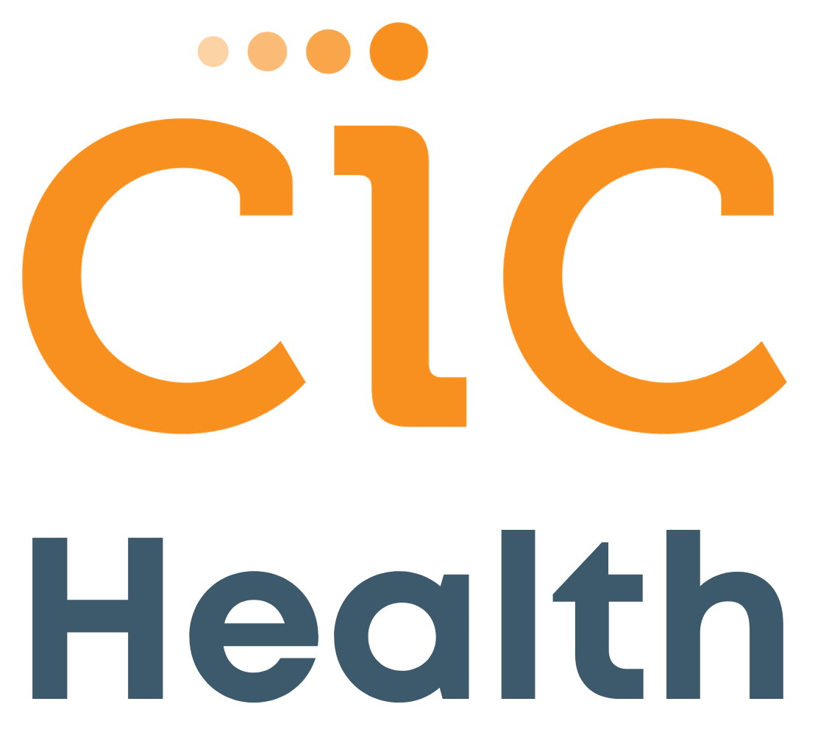
Broad Unobserved Testing Implementation Guide

Contents

- Overview

Description of the program
  - Outline of responsibilities by CIC Health and by your organization

Personnel needs by your organization
- Broad Unobserved Collection Site Instructions

Supplies
  - Setting up your testing day flow

Packaging & Shipping
- Software
- Pre-Accession

Section 1: Overview

Description of the Program
The Broad Unobserved collection requires organizations to set up Device Pick-Up and Drop- Off site(s) with the required components (waste, computer access, barcode printer, etc.), and trained staff to obtain consent, provide basic quality control of samples, and prepare for transport.

A Medical Professional is not required at the testing site to supervise the process.

Responsibilities of CIC Health and Testing Organization

 | Y U | C C HE L H &  E
Training on best practice to set up your testing program and collection site
Delivery of sample collection kits to your sites (see section 2.7)
Software Portal for uploading participant data and receiving results
Physician's order to authorize testing of asymptomatic community members
Test participant administration, including waiver management
Laboratory sample processing
Reporting test results to both designated organization health officials and directly to participants.
Required public health reporting to relevant authorities.
Physician follow-up support for positive test results, and physician referral services for further follow-up.
Site setup and logistics at your site (printing labels, loading data into software portal, setting up collection tent, etc.).
Ongoing site supplies (see section 2.7)
Registering and loading participants into the software portal provided by CIC Health.
Collecting samples from participants at your site.
Appropriately packaging the completed sample collection kits and sending samples + manifest from collection site to a pre-screening for quality control before heading to the CRSP Laboratory for processing.
Appropriate handling and storage of specimens in accordance with CRSP and CDC guidance on handling COVID-79 samples.

  - Personnel needs by your organization

Please note these requirements can be accomplished by one person or by multiple. More support by your organization may allow for faster testing standup.

IT/Tech person
o To support uploading and downloading files into the software, to help with label printer driver install, and to ensure the organization’s network settings can support patients and staff access.
    - Project manager for gathering and managing testing site supplies needed
    - Administration to perform intake, sample collection and manifest creation
      - An administrator should oversee sample collection
      - This work could be one person or divided into multiple roles depending on the number of people testing
      - Manifest creation: creating the manifest (or overview of samples being submitted, completed by filling out the form in Appendix C
      - Packaging and shipping tests to the lab

Patient Account/Results Manager and Communication Coordinator
      - To provide on-going communication to, and administrative support for the testing community, including defining a designated email contact for patient questions.
        - Organizes outgoing communication to the testing community about the testing program, including where and when they should go for testing.
        - Uploads patients into software or emails patients the link and site- specific code for patients to upload themselves into the software
        - Provides HR (or equivalent) results management (as needed)
        - Provides administrative support including Patient/staff account activation emails and password resets.
        - Designates an email address for patients (and their guardians) of the testing community to contact with questions.

Section 2: Broad Unobserved Collection Site Instructions

Supplies
Test kit materials are shipped to each test site from CRSP at Broad Institute. While other tests for SARS-COV-2 require staff to wear additional PPE per CDC guidelines, the anterior nares (nasal swab) specimen collected by a healthcare provider or by home or supervised onsite self-collection (using a flocked or spun polyester swab) allows testing sites to minimize the number of staff needed and amount of PPE used. The anterior nares PCR test is the test currently utilized in testing provided by CIC Health and the Broad, and any updates as to the kind of testing utilized by CIC Health and corresponding new requirements for organizations will be clearly communicated.

Supplies provided to you by the Broad:
    - Cardboard cryoboxes with 64 place fiberboard cell dividers: These are the boxes in which submitted collection tubes will be placed upright when being packaged for shipping
    - Cardboard box for shipping
    - CRSP address labels
    - Dymo Labelwriter 450 printer & Dymo 1”x2.125” Durable Small Labels #1976411
      - *Note, please do not use the labels that come in the Dymo printer box – use the labels that are packaged separately from the printer!
    - Unobserved Self-Swab Nasal Collection device which includes 1 anterior nasal swab, 1 collection tube, and 1 instruction sheet in a sealable bag. Here’s a sneak peek at what this looks like:

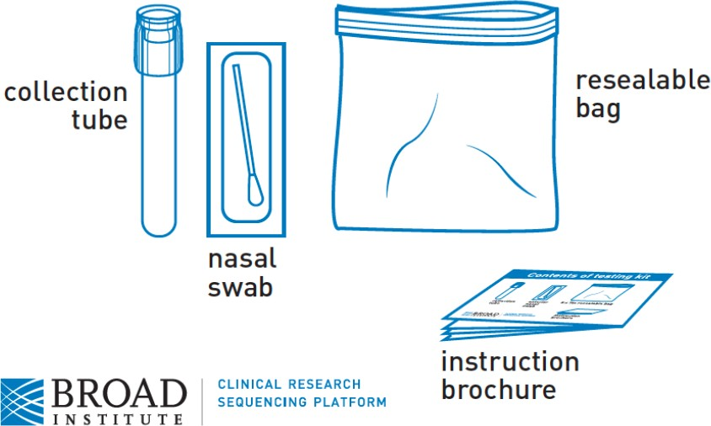

Supplies procured by your organization:
    - External rigid cardboard shipping box: must be able to withstand impact if dropped, per Category B shipping requirements (see Section 2.3 for more information)

UN3373 - biological substance shipping label
      - Either roll of label stickers
      - OR printable version UN 3373 Biological Substance, Category B Air Labels (4¾” x 4") to tape to the box
    - Packing peanuts or bubble wrap, and packing tape: used to fill remaining space inside the shipping box for snug packing
    - Rubber bands to close the cryoboxes.
    - Windows-based laptop with USB port and WiFi access
    - Standard printer for paper manifest that needs to be sent with each package
    - Tissues for participant station

Trash cans
    - Hand sanitizer
    - Disinfecting solution: spray bottle; ethanol, 70% alcohol.

Paper towels
    - Gloves small, medium, and large.
    - Electricity or electric generator (as needed)
    - Extension cord (as needed)
    - Power strip (as needed)

Internet connection

We also suggest that you procure additional supplies of the following, beyond what the Broad provides, in the instance you may need to retest or break your testing into multiple shipments:
- LW Multi-Purpose Labels, Small 1" x 2 1/8" SKU: 30336
- Cardboard Cryobox (5-1/5 x 5-1/5 x 4"): Product number 89214-738 (box) The Broad sends these with the testing kit, but depending on how you are filling the cryobox(es) each day, you may need to have extras on hand. Product numbers: 89214-738 (box).
- Cryobox Divider Insert Cat# CD-64 (64 place). Fits VWR cryobox listed above. The first options available will default to 100 inserts, please make sure you are ordering the 64 insert divider as it will fit the test tube size.

Setting Up your Testing Day Flow

Determine a Test Kit Drop off Location & Flow
Before distributing the collection kits, you’ll want to determine a secure drop off spot and deadline for returning samples and communicate this to all individuals being tested. The drop-off stations are not required to follow the full guidelines for a collection site regarding emergency procedures, telephones, restrooms, etc. However, adequate hand washing/hand sanitizing stations are highly recommended given that re-collection of some swabs may be required. Drop-off stations require a staff member (or multiple) to confirm identity, inspect and label each sample.

Each site is responsible for operating the Drop off Locations. Consider the flow of participants at your site based on CDC guidelines, including adequate PPE & sanitizing procedures and maintaining a minimum of 6 feet distance between participants.

Distribution of Testing Kits
At the beginning of the testing day, distribute the kits to your patients, along with the patient guidelines document (see Appendix B). We recommend you require all patients to collect their samples as soon as possible and return them no later than two hours before you plan to ship them out. We also recommend provision of tissues and hand sanitizing supplies for test participants (See Appendix A.)

Drop Off Procedures for Site Administrators/Staff
These are steps to outline the flow for site administrators at the drop off station, while the patient is physically present returning their specimen.

  - Receive the bagged sample from the patient.
  - Open bag to retrieve the sample and discard bag. Please note: while these are biohazard bags, they can go in regular trash because they should never have specimen in them.
  - Inspect sample tube ensuring that:
    - Tube contains one swab. If zero or more than one swab is in the tube, use proper PPE to discard all swabs. Issue a new swab and direct participant to a private area to recollect.
    - The existing single swab in the tube is oriented correctly - with soft tip facing down (away from cap). If swab is incorrectly oriented, use proper PPE to discard the swab. Issue a new swab and direct participant to a private area to recollect.
    - Check to see if ‘solid biological contents’ are in the tube. Swab may be ‘dry’ or ‘moist’ or slightly ‘bloody’ without issue, but solids can cause issues with automation downstream. If there is significant visible matter on the swab (a.k.a. snot or excessive mucus), use proper PPE to discard the swab. Issue a new swab and direct participant to recollect.

*Please see section D for visual aides in sample inspection procedures.

  - Confirmation of Collection Time and Sample Registration
    - Collected Time = ask participant when they collected their sample. Confirm that participant collected sample today. Record the time and today’s date.
      - If sample collection was not same day as drop-off, reject sample and discard. Issue a new device and direct participant to recollect.

Print the barcode. See section 3.2 for instructions on how to print the barcode from CareEvolve.
    - When barcode prints, visually inspect quality of barcode printed to ensure no scanning issues (no fading, blurry lines, missing info, etc.) Ensure there is a clear distinction of black and white lines.
    - If the barcode has any abnormality in print quality, reprint.
    - Confirm the name, DOB, zip code, and information on the patient’s barcode label is correct.
    - Affix the barcode label to the collection tube - making sure it is upright and flat on the tube (not crooked or creased) and flush with the bottom of the cap.
- Do not put barcode sideways.
- Do not put barcode on top of any other label.
- Do not tape down barcode
- Do not place barcode over cap.
    - The reason the labels need to be put on so precisely is because the barcode scanner that the Broad uses is very particular, and won't be able to read the barcode unless put on correctly. If the label is not properly placed on the test tube it is likely the sample will be discarded by the lab and thus not yielding a result.
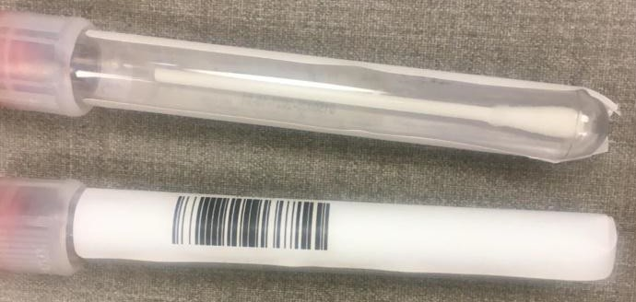
Image Description: A properly placed label with no creases or on an angle

    - Place the now properly labeled sample tube upright in the cryobox with inserts for scheduled transportation to the laboratory.
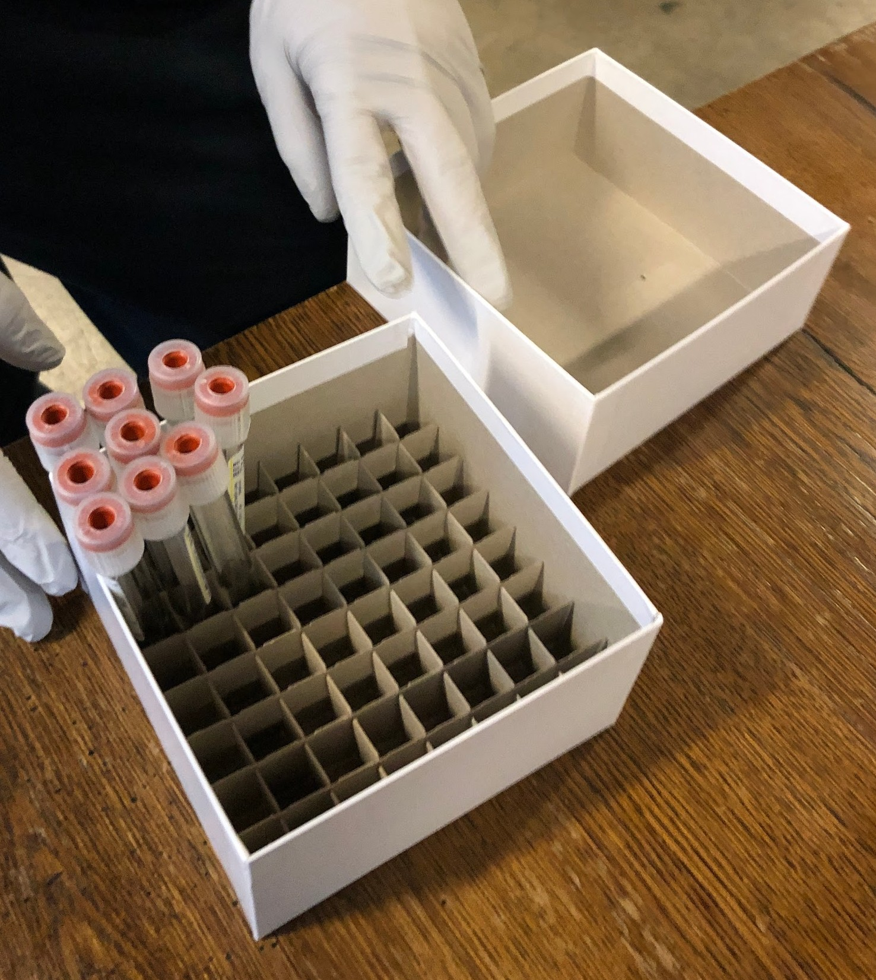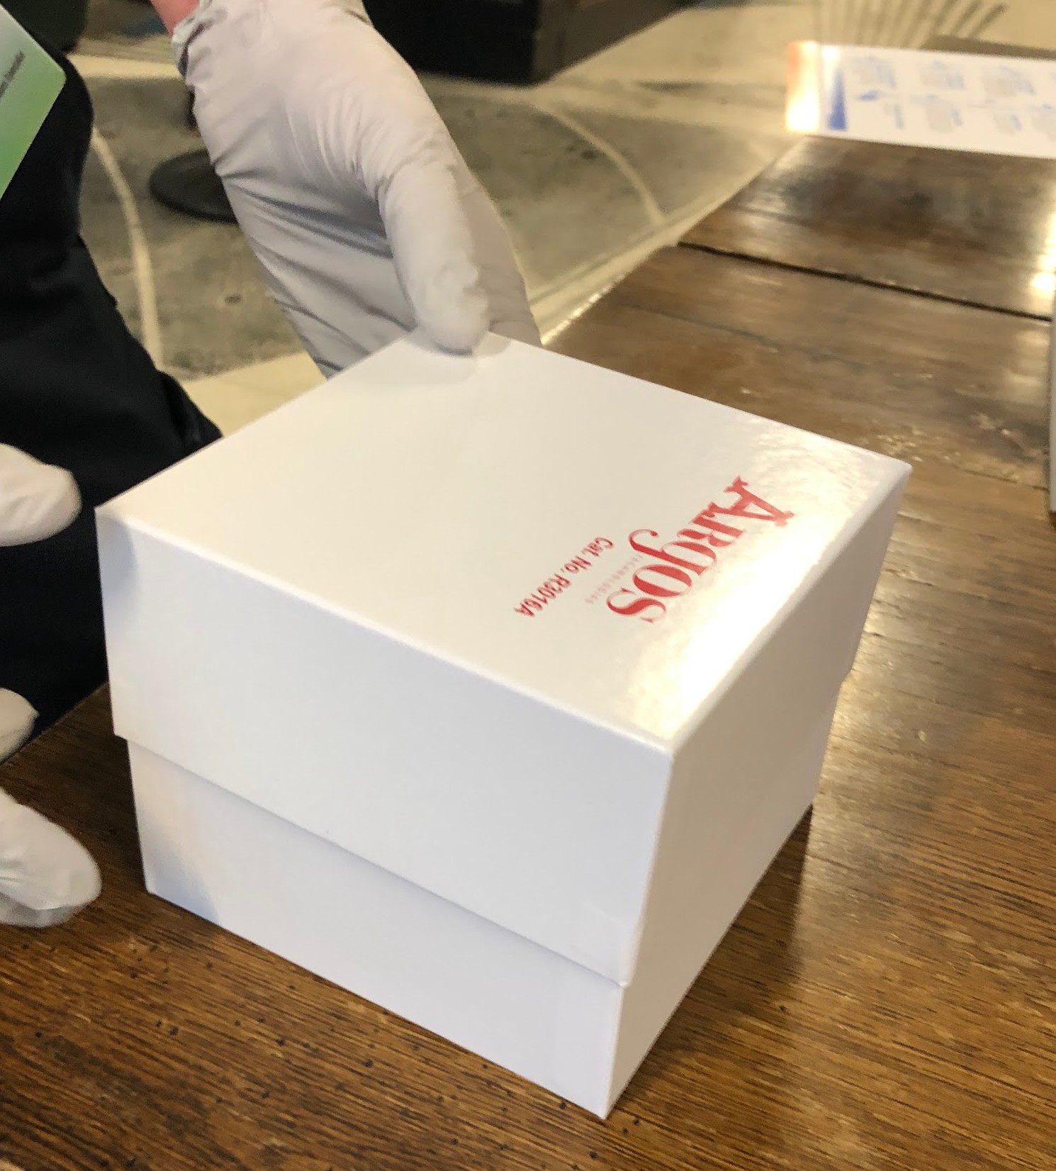
Image Description: Organized test tubes standing upright in a cryobox with inserts

Sample Inspection
As you receive samples from each patient at the drop off location, remove each tube from its plastic bag and inspect the sample for any errors that require retesting (see below). Then verify the appropriate label and apply the label to the tube. The following are errors that may result in a sample being discarded by the lab and thus not yielding a result:

Label Application Errors to Avoid
- Wrinkled/Creased/Angled label
- Label smudged or otherwise obscured
- Patient information cut off
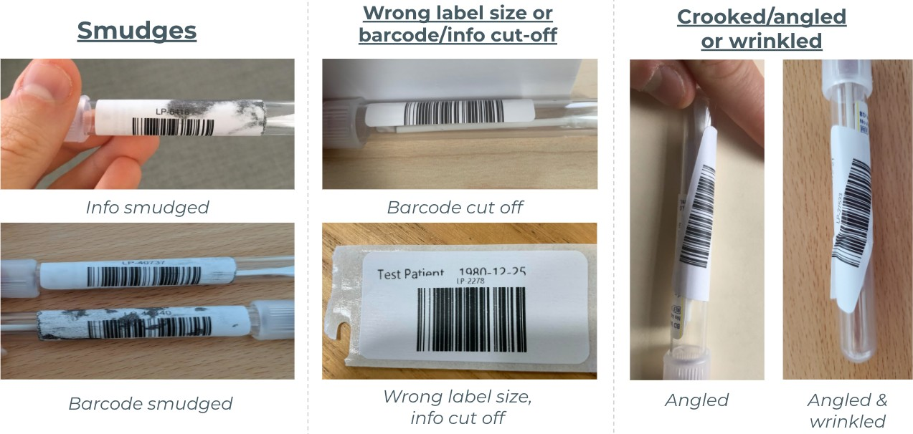

Errors that require a patient to reswab
- Swab oriented incorrectly
- Blood, mucus on swab
- Fluffy swabs
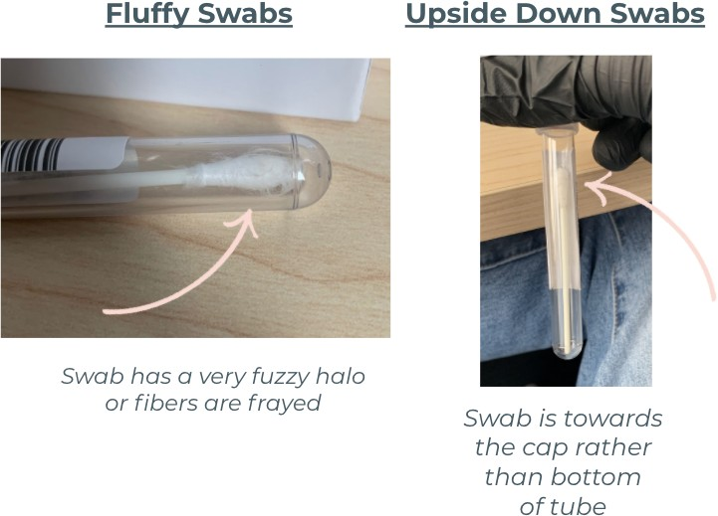
If one you see a sample with the swab upside down, an overly fluffy (pictured below), or a sample with blood or mucus, you should discard the swab and ask the individual in question to recollect.

Packing & Shipping

Establishing Delivery Plan

Prior to test day, confirm samples can be picked up by FedEx or UPS or dropped off at a FedEx or UPS drop off location prior to last drop off time.

Through your shipping service, select a shipping speed that will ensure your samples arrive to the lab within 48 hours of collection. Shipping Address:

CIC Health 245 Main Street
Cambridge, MA 02142

857-270-2707

Contact number: 857-270-2707
Delivery Instructions: M-F, 9am-5pm, please bring packages up to the second floor Concierge; outside of business hours, please instruct couriers to ring the doorbell at the entrance to 245 Main Street or call 857-270-2707 and wait for someone from our team to come down to retrieve the packages.

Drop off is available 24/7: Please communicate to your hand delivery team member or to your courier that they must hand off the packages in lieu of leaving them outside; if they ring the doorbell and there is a delay, it is likely because it is taking two minutes or more to come down to the door from upper floors. Please be patient, because someone is coming, and having samples directly handed to pre-accession at 245 Main helps increase efficiency and overall turn-around time on your samples.

Weekend Delivery
If you are planning to ship your samples during the weekend, please provide your Program Associate with the shipping service and tracking number(s) for your shipping boxes so that they are able to monitor the progress of your shipment. This would be greatly appreciated!

If Shipping with FedEx or UPS: please note the sender needs to check "Saturday delivery" on the shipping form or else the box may not be delivered until Monday.

Packing & Shipping Specimens
  - As test tubes are collected at the designated drop off station, please consolidate the samples in the sample cryobox dividers to make complete racks of 64 tubes per Cryobox.

  - Physically count all the sample tubes and complete the Manifest/Packing Slip (Appendix C.)

  - Seal the Cryobox lid shut with tape or elastic band. Consolidate sealed Cryoboxes into as few shipping kits as possible. Do not use any wet ice for packaging. Dry specimens are stable long term at room temperature.

  - Place the completed manifest/packing list (Appendix C) in the shipping box. If you have multiple shipping boxes, please include a copy on the Manifest/Packing Slip in each shipment.

  - Pack the shipping box with packing materials so the cryoboxes do not shift around during transport.

  - Seal the shipping box shut with tape.

  - Through your shipping service, create your shipping label for expedited delivery to the following address. Shipping Address:

CIC Health 245 Main Street
Cambridge, MA 02142

857-270-2707

  - Affix the sender’s label to the outside of the shipping box. Ensure that the sender's company name, address, contact name, and contact phone number are included on the label.

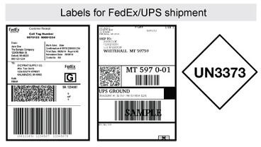
Examples of sender's address labels. If using FedEx or UPS for shipment, please include UN3373 labels and mark the shipment as "Biological substance, Category B" in addition to the sender's address labels specific to that courier in compliance with UN 3373 Biological Substance, Category B shipping regulations.

  - When shipping with FedEx or UPS, ensure we follow the Category B shipping requirements for packages containing biological substances. Affix a UN 3373 Biological Substance, Category B Air Label to the outside of the shipping box. Per the CDC shipping recommendations, place the label on one side of the box and cover the label completely with clear tape (do not tape just the edges of the label).

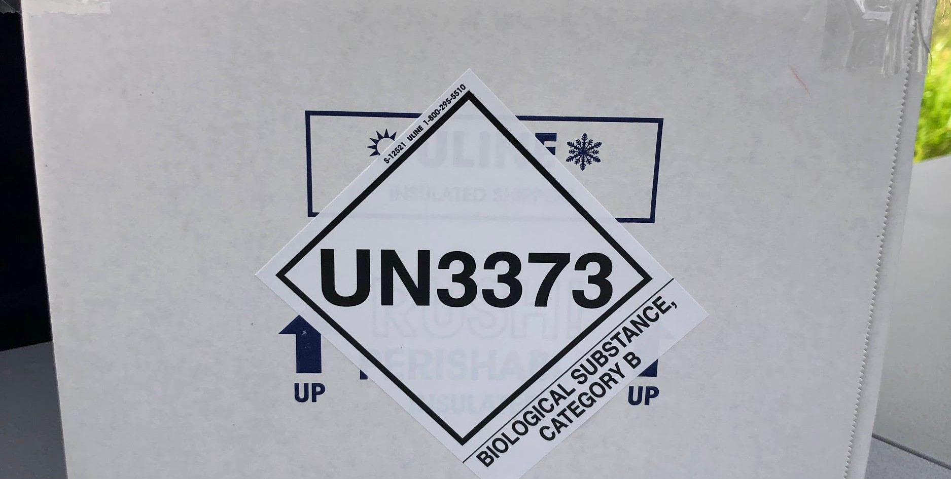
  - Ensure your samples are packaged and available for handoff at your arranged UPS pick up time or bring to a UPS drop off location prior to last drop off time. The shipping service should be next day delivery.

Section 3: Software Onboarding

Broad CRSP CareEvolve: Setup, Training, and References
    - Setup of your “Practice” in CareEvolve will be completed by the VDH

For CareEvolve Administrators Only: Adding CareEvolve users to your Practice
      - CIC Health personnel will add at least one Practice Admin and one Provider to your Practice
      - Practice Admin can add new users as needed (orderers, results viewers, etc)
      - Possible roles for site personnel:
        - Practice Admin - create/delete new admin users; edit user roles; create orders/manifests; view results
        - Full CareEvolve Access - create orders/manifests; view results
        - Lab Ordering Only - create orders/manifests
        - Results Only - view results
        - Patient ID Only - create orders/manifests (view patient ID only; not frequently used)

Loading Patient Information into CareEvolve
      - Option 1: Manually add (aka “Walk-Ups”): See section 3.2
      - Option 2: Pre-load patient information in bulk by filling out and submitting a csv template to CRSP via secure transfer

On-Site Collection Software Flow

Ordering Tests
      - For “Walk-Ups”,
- Patient > Add Patient
- IMPORTANT: Verbally confirm patient identity and validate demographic values
- Fill out required fields (fields in red are required)
- Confirm with patient that entered values are correct
- “Save and Order”
- Complete Ordering screens
- Print barcode (See Section 2.2.C)
- Apply barcode to tube

For pre-loaded patient info, Patient > Search for Patient

- IMPORTANT: Verbally confirm patient identity and validate demographic values
- NOTE: Fields highlighted in red require update / amendment.
- “Create New Order”
- Complete Ordering screens
- Print barcode (See Section 2.2.C)
- Apply barcode to tube

Quick Reference Guide: Order Entry
Quick Reference Guide: Order Entry

Patient Search
Ordering

To begin searching for a patient, you can either click the magnifying glass at the top right-hand corner fo the page or go to “Patients” and click “Search Patients”

Select the patient from the returned list.

Add Patient
If the patient does not exist, use the Add Patient
button or Add Patient page under the Patients
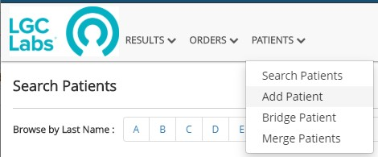
Enter the patient's demographics information.

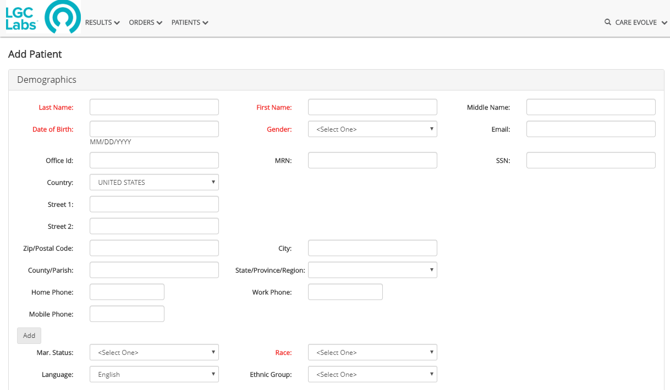Click Save, Save & Place Order or Cancel

PATIENT TAB
- Use the dropdowns to select:
  - Order Type - Draw Now
  - Bill Type - Client
  - Order Information - Select Ordering Provider
- Confirm Patient Demographics and enter any missing
required information.

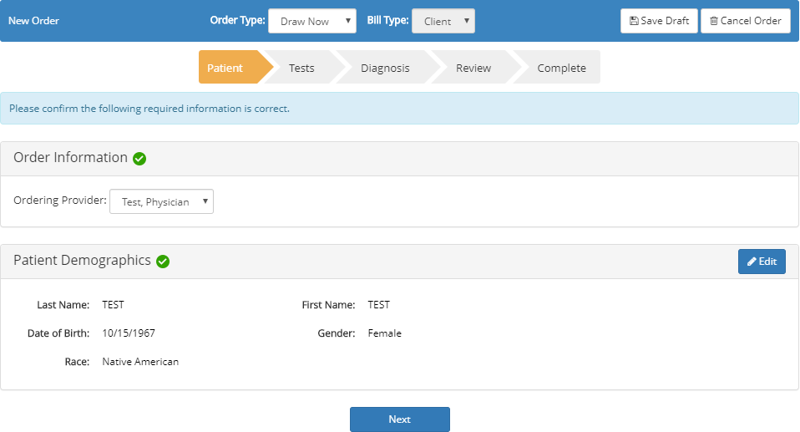
TESTS TAB
Use the search field to locate test or select from prefilled list; then click “Next”.

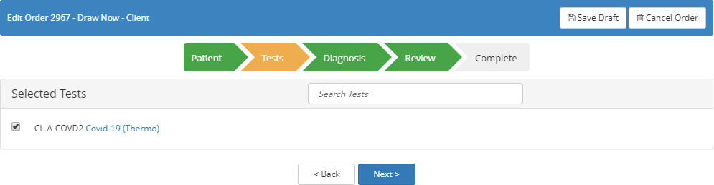

DIAGNOSIS TAB
Use the search field to locate diagnosis or select from prefilled list; then click “Next”.
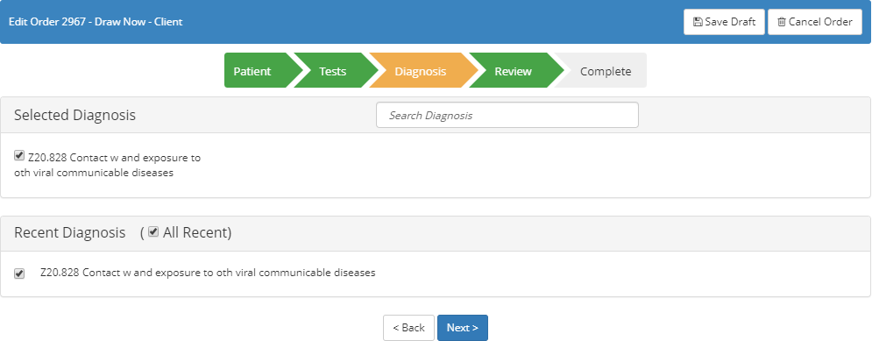

Page 1 of 2

Quick Reference Guide: Order Entry
Ordering (continued)
REVIEW TAB
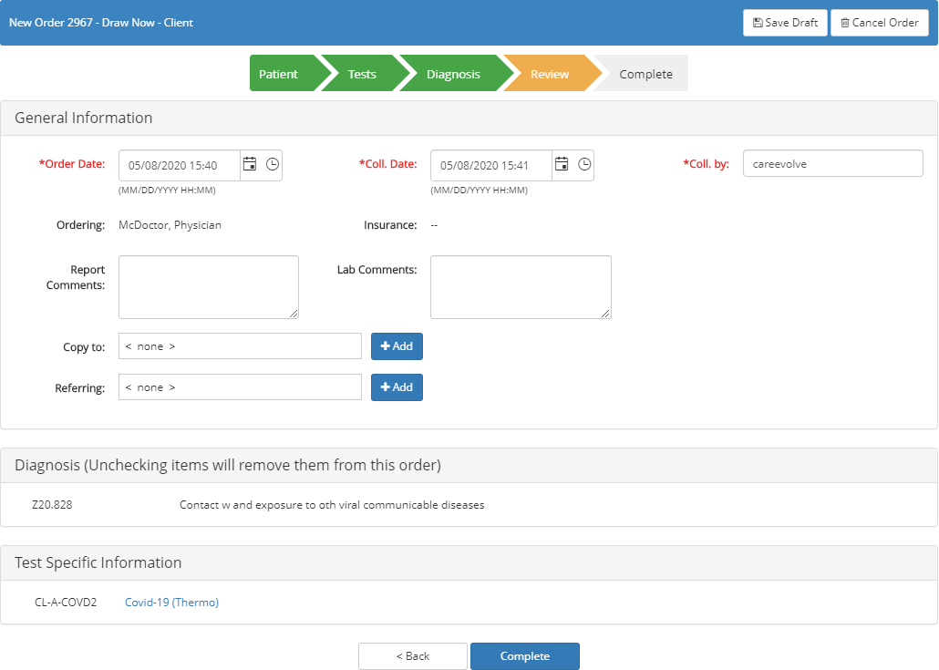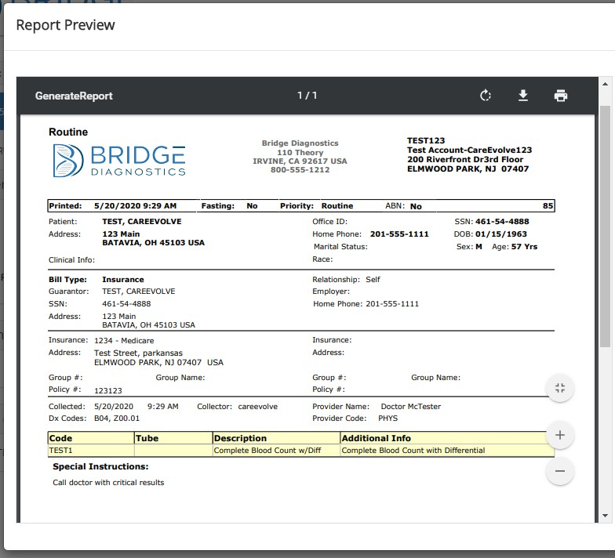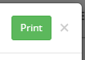Complete *required fields and other available fields, as needed. Click the Complete button to view and print the order requisition and label.

NOTES:

Page 2 of 2

Section 4: Pre-Accession

  - What is Pre-Accession and Why is it Needed?
Broad and CIC Health are very appreciative of our pre-accessioning team who are reviewing each submitted sample to reduce the likelihood of sample error. They are tasked with reviewing each sample that gets collected, fixing any preventable errors that would slow down or halt the Broad's process, and correcting any manifest issues. The pre-accessioning team receives the samples at 245 Main Street, and helps sites reduce the likelihood of TNP and inconclusive results. As such, you may see someone from the team with a "smartcarecic" email address added to your account as an L3 clinician. Through this access, they will be able to reprint labels as needed, but are not able to review results associated with accounts.

The “pre-accessioning” process allows us to correct software errors, most user errors, and maintain the quality control needed on our samples before they reach our testing partners at the Broad Institute. The Broad has created a novel automation system for COVID-19 test processing that is scalable, modular, and high-throughput, running like an assembly line, which you can see a behind the scenes video here. Any errors—any crooked labels, upside down swabs or smudged barcodes—force the Broad’s testing processes to a halt. CIC Health’s pre- accessioning prevents these stoppages before they happen at the lab, and fewer issues in need of resolution expedite the receipt and turnaround of samples. The fewer errors that are included in your sample collection, the faster pre-accession and laboratory processing will be, ensuring as little delay as possible in receiving your test results.

See section 2.2.D for common errors that are fixable and non-fixable.

Appendix A: Broad Instructions for Unobserved Self-Swabbing
(Included in each Self-Swab Kit)
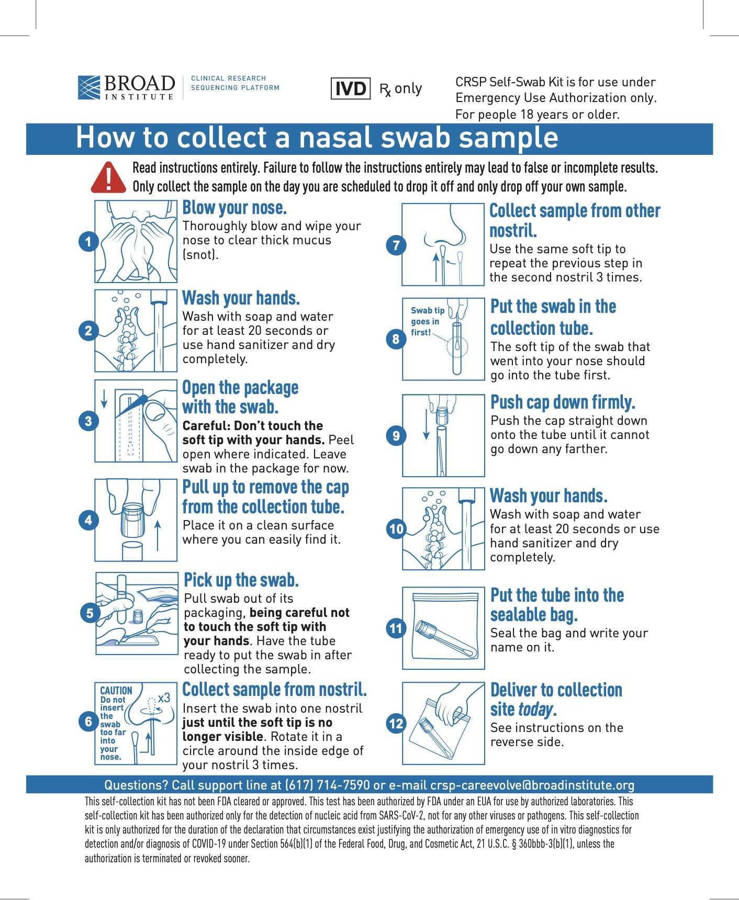

Appendix B: Participant Guidelines for Unobserved Sample Collection
(Print for Participants)

Participant Guidelines for Unobserved Sample Collection

    - Participants will be instructed by their organization on frequency of performing the test and schedule of pick up and drop off. Participants will be instructed to test ONLY on the day of scheduled dropoff date.

    - Pick up a test kit bag from the designated location.

    - Find a secluded area or a spot at least 10 feet away from others to perform the self swabbing. All participants will need to have tissues and hand sanitizer in order to perform the specimen collection.

    - Open up the resealable bag and follow the instructions for specimen collection on the brochure. Failure to follow the instructions entirely may lead to false or incomplete results. Make sure to:
      - Thoroughly blow and wipe your nose to clear thick mucus (snot) before swabbing
      - Wash or sanitize your hands immediately before swabbing and after placing swab securely in test tube
      - Place the swab’s soft tip into the tube facing down (towards the bottom of the tube)

    - Once the test tube cap is securely closed and the tube is sealed in the bag, please return to the designated drop off area as directed by your organization.

    - Participants will hand resealable bag containing the test tube to the staff administrator at the drop off site.
      - If there is blood or excessive mucus on the swab, the staff administrator will ask you to retest with a new swab. If you notice either blood or excessive mucus please request to retest as these issues may not yield a result.

    - Participants will verbally confirm that the name, DOB, zip code and information on the barcode label is correct to the staff administrator.

Appendix C: Manifest / Packing Slip
(Print to include in shipment to the lab)

Specimen Manifest
Clinical Research Sequencing Platform Covid19_Diagnostic
320 Charles Street
Cambridge, MA 02141-2023

* Please fill in all 4 of the fields below before shipping to the Broad *

Sending Institution:
Sending Institution and Collection Site Address

Collection Date Range:
Date range of specimen collection. Can be a single date if collected on same day

/ / 20
To:

/ / 20

Total Specimens:
Total count of specimens in this package

Package Number
Package number of total in Shipment. ex. Package 2 of 3.

Package of

